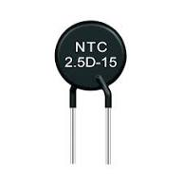
NTC Thermistor ek temperature-sensitive resistor hota hai jo starting surge current ko control karta hai.
Cold state me resistance jyada hota hai, garam hote hi resistance kam ho jata hai.
NTC = Negative Temperature Coefficient
Matlab temperature badhne par resistance kam hota jata hai.
Use Case + Connection Syntax
SMPS / Inverter ke AC input line me series me


Surge Current
Note:- Surge ka matlab hota hai – achanak bahut jyada current ka flow hona, jo normal se kai guna zyada hota hai, sirf power ON karte hi.
Short Definition
Surge Current = Starting time par aane wala extra high current spike.
Use Case + Example
Jab hum SMPS / Charger ON karte hain:
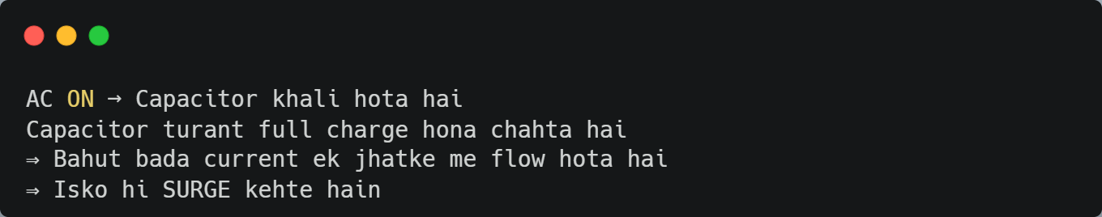

Real World Relation
Without NTC | With NTC
Fuse ud jata hai | Fuse safe
Bridge rectifier burn | Circuit safe
Capacitor damage | Long life

👉 One Line yaad rakho:
Surge = ON hote hi aane wala dangerous high current jhatka.
